Succes Story of School Adoption Programme
Government Public School, Gintigaon ( Ramnagar Project)

Government Primary School (GPS), Gintigaon is situated in Gintigaon village of Kotabagh block and Nainital district, Uttrakhand. This is a school that has created an example by retaining students and increasing the number of students’ attendance in the school with the support of Nature Bio Food’s CSR initiative.
Challenges:
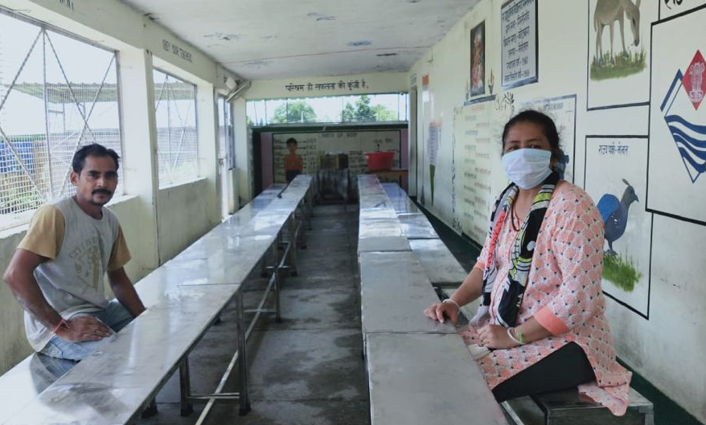
GPS Gintigaon is the only government school in this village. The villagers mostly earn their living by farming and daily labour work. The children comes to GPS Gintigaon are from these farmers families and other EWS families. Most of the parents were not in a position of sending their children to any Private school, but then also some of the parents somehow sent their children to the private school. In the year of 2018 this school only had 18 students & two teachers including the HM.
Government officials already had decided to close this school due to this low attendance of students, but scenario changed in the year 2019 when Nature Bio Foods adopted this school under the CSR initiative of NBF. Team of NATURE BIO FOODS identified this school and came into contact with the HM of GPS Gintigaon. Through detail discussion with the HM & teachers and through home visits and parents’ interaction NATURE BIO FOODS team found out the reasons of low attendances & the challenges were –
- Poor infrastructure of school building.
- Unavailability of Drinking water facility.
- Unhygienic Washroom facilities.
- Poor classroom conditions.
- Poor condition of available games materials and academic resources.
- Unprotected school campus.
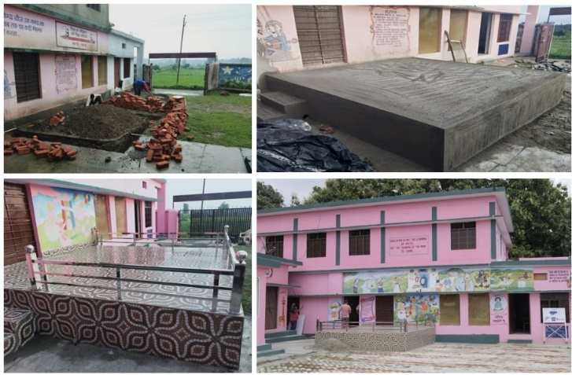
- Poor coordination among SMCs & Parents and teachers.
Initiatives Taken:
NATURE BIO FOODS adopted this school in 2019 and started their intervention in the school for the development. NATURE BIO FOODS did an inauguration event in the school. The objective of the project intervention was to bring back the students in the school by providing all kind of necessary support to the school administration. NATURE BIO FOODS believed that the farmers who are engaged in Basmati rice production for the company, should not face any problem for the betterment of their families and children education. Especially children should go to the schools and NATURE BIO FOODS would do the developmental work in those schools. NATURE BIO FOODS field team members & SMTs did visit and meeting with HM and local education officials like BEO, ABEO, BRC and also with the BDO to get the approvals for project interventions in government school. In the request letter the HM requested the following support for school –
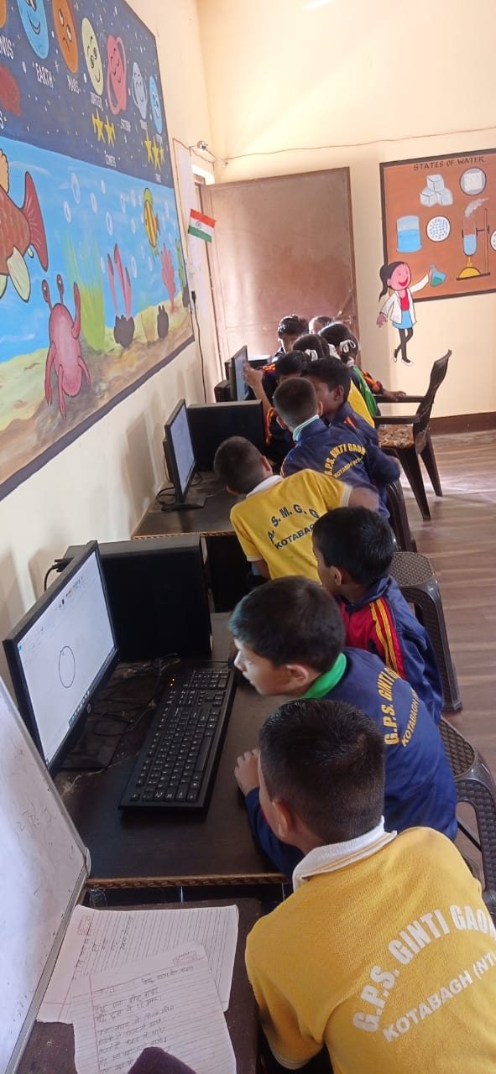
- New constructions of toilet units in school.
- A stage in the ground for conducting prayers and other events in schools.
- Dining table and benches for the children for Mid-Day meal.
- Digital classrooms support
- Water filters.
At the first phase of its intervention NATURE BIO FOODS constructed the prayer stage in the ground and then toilet units with all the modern facilities for boys and girls. Wash basin installed and proper drainage system for the toilets and hand washing basins were constructed and also purchased dining table and benches for 100 children for their Mid day meal.
Visible Changes:
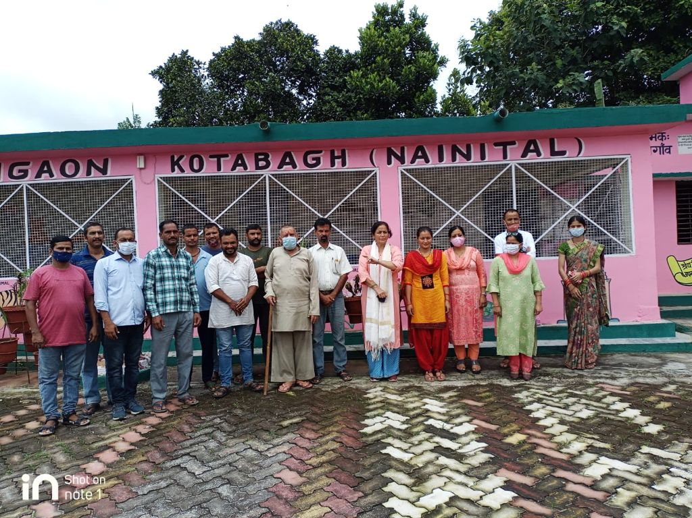
All the efforts and supports from NATURE BIO FOODS and regular home visits and parents’ interactions by HM and others teachers started to bring back the students to school. The SMC supported in the process as well by conducting regular meetings. The local government officials came forward to support the school by providing other infrastructure and academic support. Currently the school campus is protected by a boundary, number of teachers increased and classes are continuing properly, now students can have their MDM sitting on the table and benches, students have a proper toilet facilities which helps the children to maintain hygiene and be healthy.
All these development in the school brought a visible changes in the student strength which now increased to 128 students till this year from merely 18 student in 2018.
Student are also happy to have their new computer classes in the school
“It’s the initiative of NATURE BIO FOODS that turned the wheel and we decided not to close down the school, as the students’ numbers were increased. Moreover we decided to support the Gintigaon School in growing in all aspect and with all kind of available resources”. -
ABEO, Kotabagh Block

“Prior to NATURE BIO FOODS others organizations also came to support us, but none of them continued with their efforts as NATURE BIO FOODS. NATURE BIO FOODS tem members and SMT always were proactively supported us for the betterment of the school. Whatever we requested for the school NATURE BIO FOODS provided. Me and my teachers along with the children very happy with all the works NATURE BIO FOODS did and is doing”.-
Mrs. Mamta Gupta, HM , GPS, Gintigaon ( Ramnagar Project)

